|  |  |  |
| --- | --- | --- |
| **LAB 321Assignment** | **Type:** | **LongAssignment** |
| **Code:** | **3** |
| **LOC:** | **250** |
| **Slot(s):** | **10** |

**Title:** Airline Tickets – Administrator site

**Background**

Have you ever travelled by airplane or booking a plane ticket? See how the administrator manage the data of website and bookings.

**Program Specifications**

Program an airline tickets, detail functions of this website is described below

**Features:**

This website contains 06 (six) main functions

* Function 1: Login page ( see figure 01)
  + The users must be a manager user to be able to login to system.
* Function 2: Location Management page ( see PIC 02)
* Function 3: Aircraft Management page ( see PIC 03)
* Function 4: Flights Management page ( see PIC 04)
* Function 5: Bookings Management page ( see PIC 05)
* Function 6: Users Management page ( see PIC 06)

Note: All data must be load from database, not hard code.

***Expectation of User interface:***

Pic 01: Login Page ( TOP)

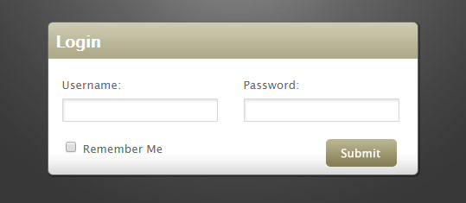

PIC 02: Location Management Page

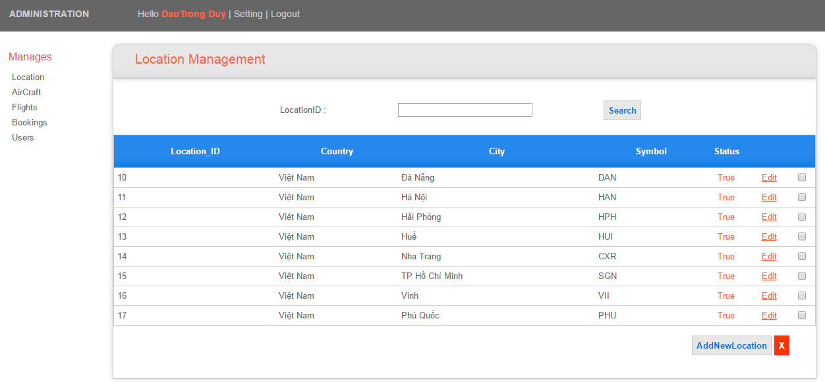

Pic 03: AircraftManagement Page

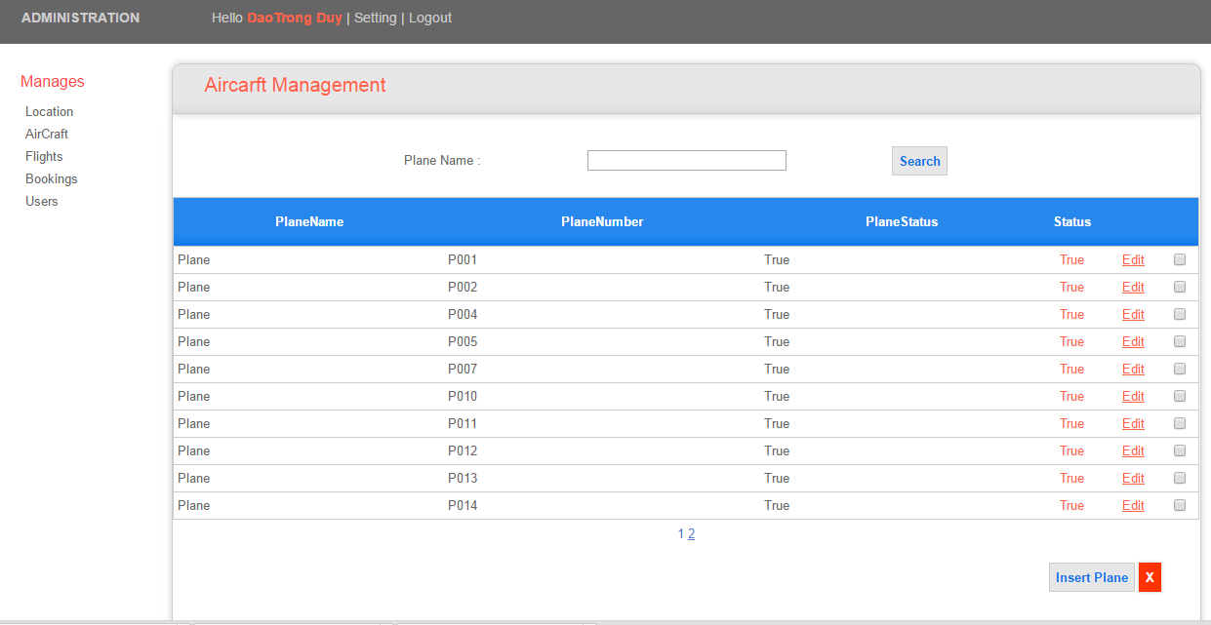

PIC 04: Flights Managementpage

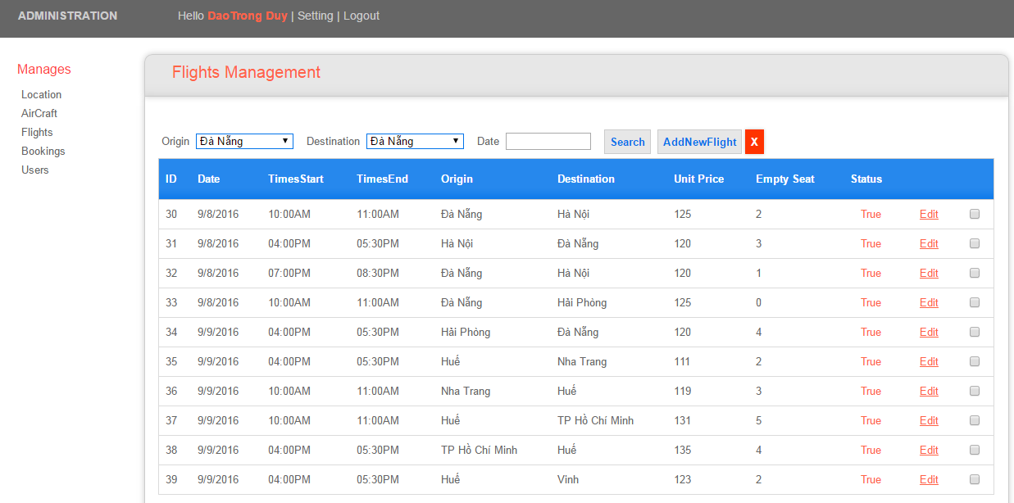

Add new Flight

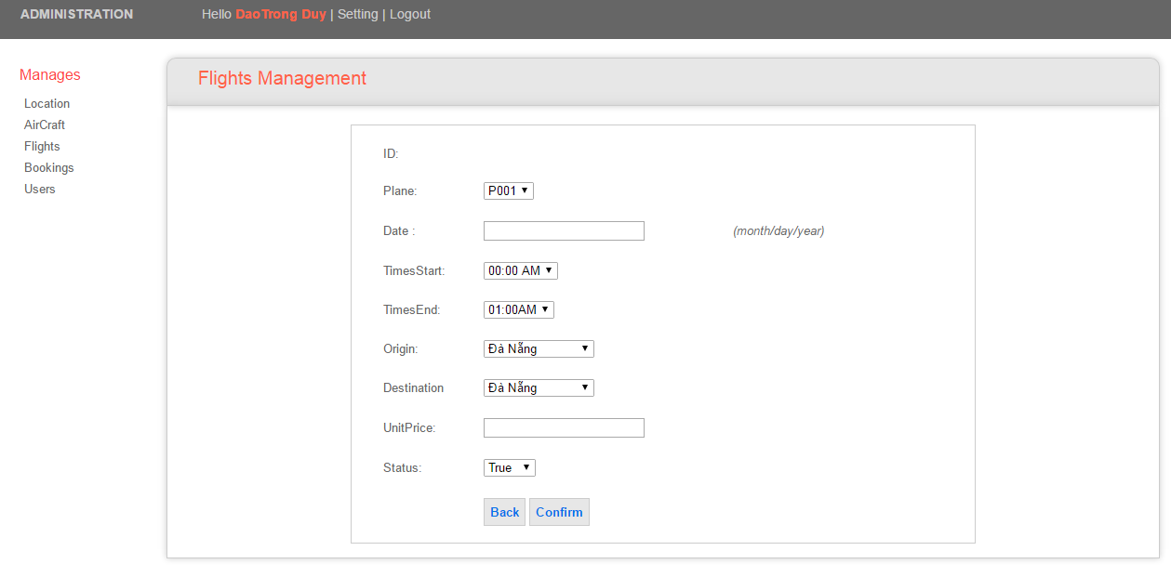

PIC 05: Bookings Management

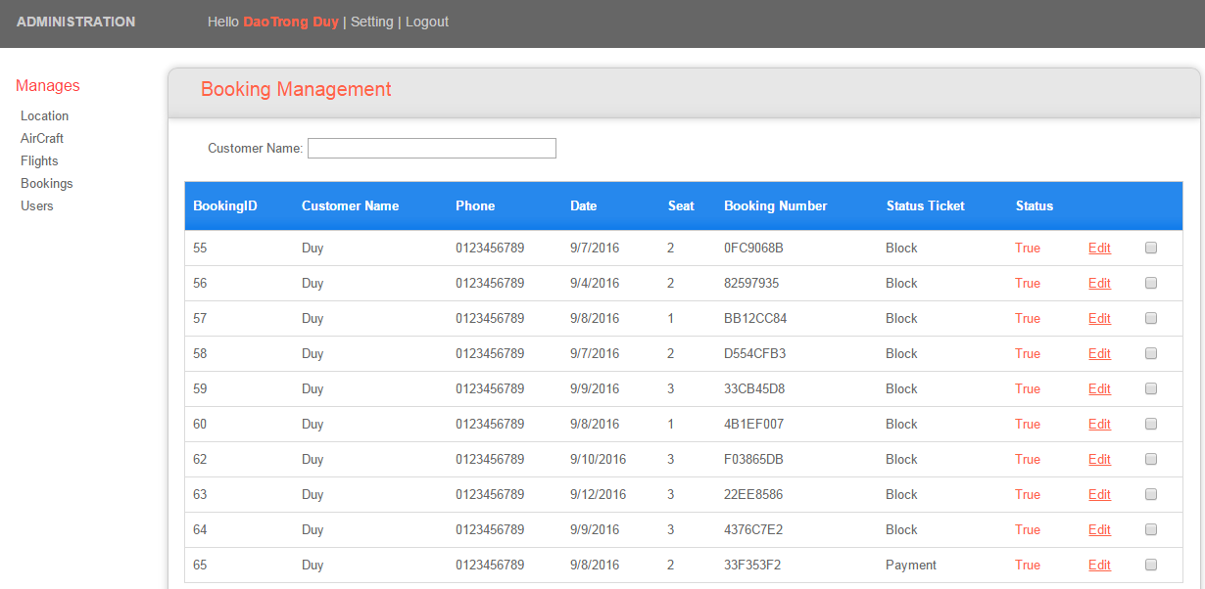

PIC 06: Account Management

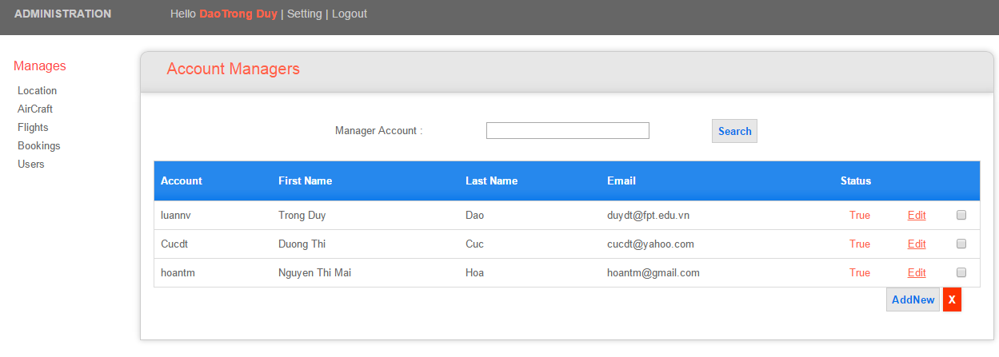

**Guidelines**

* Step 1 : Create prototype
* Step 2 : Design database base on created prototype
* Step 3 : Code & Test